Project Report – Project on recognizing areas to set up Food Trucks

**Introduction**

The City of New York, being the most populous city in the United States and situated on one of the world's largest natural harbors. It is diverse and is the financial capital of USA. It is multicultural. It provides lot of business opportunities and business friendly environment. It has attracted many different players into the market. It is a global hub of business and commerce. The city is a major center for banking and finance, retailing, world trade, transportation, tourism, real estate, new media, traditional media, advertising, legal services, accountancy, insurance, theater, fashion, and the arts in the United States. This also means that the market is highly competitive. As it is highly developed city so cost of doing business is also one of the highest. Thus, any new business venture or expansion needs to be analyzed carefully. The insights derived from analysis will give good understanding of the business environment which help in strategically targeting the market. This will help in reduction of risk. And the Return on Investment will be reasonable.

The Food Trucks industry has expanded over the five years to 2019 and is one of the best-performing segments in the broader food service sector. The industry's remarkable rise is largely attributable to changing consumer preferences in favor of unique, gourmet cuisine at less expensive prices. Cities such as Portland, OR, Los Angeles and Austin, TX, have sought to differentiate themselves by crafting laws and creating areas specially designed for mobile food trucks. These trends have been a boon for the Food Trucks industry, as consumers have sought to maximize their disposable income by indulging in small conveniences such as affordable gourmet food. As a result, industry revenue has increased significantly, rising at an annualized rate of 6.8%.

**Business problem**

The City of New York is famous for its excellent cuisine. It's food culture includes an array of international cuisines influenced by the city's immigrant history.

Food trucks have become very popular in the United States now it seems that there is one on every corner, not only in major cities but also in smaller cities. Starting a Food truck can be a great business opportunity, but you need to distinguish yourself from others to enjoy long-term success.

### Find a suitable location: If you plan a real Food trucks that can demand higher prices for fresh vegetables, delivered daily from Food trucks, focus on neighborhoods and outlets that already attract a sophisticated Food trucks client. If you plan a cheap buffet Food trucks, points to the masses looking for affordable high-traffic locations with large shopping centers and other local points of interest. So it is evident that to survive in such competitive market it is very important to strategically plan. There are various factors need to be studied in order to decide on the location

### **What Products & Services Make Up This Industry in the US?**

The Food Trucks industry consists of American, central and south american, mixed ethnicity, greek mediterranean, asian, desserts and other.

### **Industry SWOT Analysis**

The industry is exposed to the following threats and opportunities:

* The agricultural price index is a strong indicator of the prices vendors can expect to pay for the ingredients needed to prepare their meals. When the prices of these ingredients increase, operating costs increase as well, typically resulting in lower profit margins. Although the agricultural price index has been trending downward over the five years to 2019, it is expected to increase in 2019. Any rise in the price of agricultural inputs represents a potential threat to the industry.
* The industry benefits from growth in consumer spending. During times of recession, the inevitable spike in unemployment leads to declining consumption. When consumer spending is high, consumers are more likely to spend money on dining out, including at food trucks. Consumer spending is expected to increase in 2019, presenting a potential opportunity for the industry.

### **Target Audience:**

A very popular Food trucks chain is trying to open its business in Manhattan area, so I want to focus on a particular place during my analysis. The objective is to locate and recommend to the management which neighborhood of New York city will be best choice to start a Food trucks. The Management also expects to understand the rationale of the recommendations made.

This would interest anyone who wants to start a new Food trucks in New York city.

### **Data**

To find the best areas to etup for our Food Truck, we will use the following data sources:

* New York has a total of 5 boroughs and 306 neighborhoods. In order to segment the neighborhoods and explore them, we will need a dataset that contains the 5 boroughs and the neighborhoods that exist in each borough as well as the latitude and longitude coordinates of each neighborhood.

The link to the dataset: <https://geo.nyu.edu/catalog/nyu_2451_34572>

* Foursquare uses cookies to provide you with an optimal experience, to personalize ads that you may see, and to help advertisers measure the results of their ad
* From Foursquare Venues Categories - <https://developer.foursquare.com/docs/resources/categories>

Food TruckCategory Id - 4bf58dd8d48988d1cb941735

**Methodology**

In this project, Foursquare is used for location category preferences.

Convert addresses into their equivalent latitude and longitude values. Then we will use the Foursquare API to explore neighborhoods in Manhattan, New York. After that, explore function to get Foot Truck in each neighborhood.

**Clusters created for areas:**

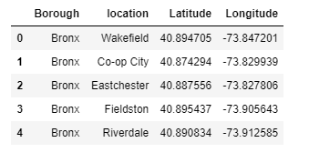

Using the feature to group the neighborhoods into clusters K-means clustering algorithm. Folium library to visualize the neighborhoods in Manhattan and its emerging clusters.

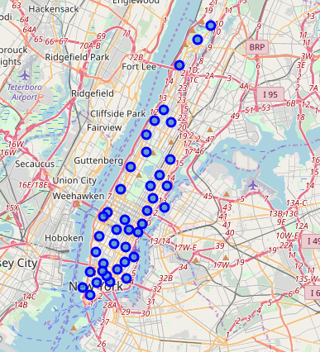

**Analysing each of the neighborhoods:**

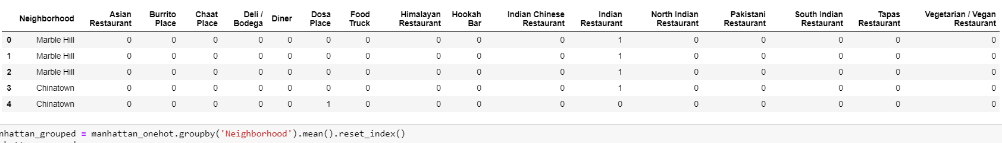

**Food Truck in various neighborhoods:**



**Grouping the locational data:**

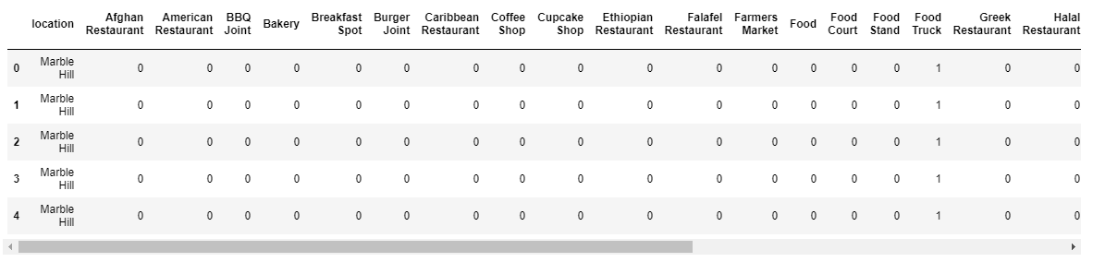 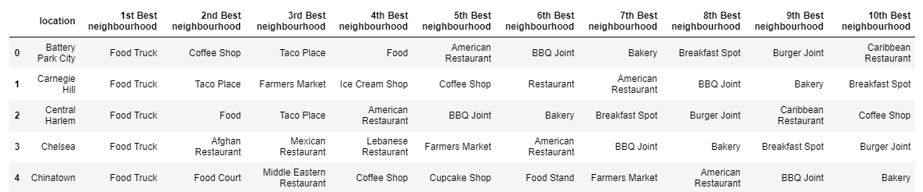

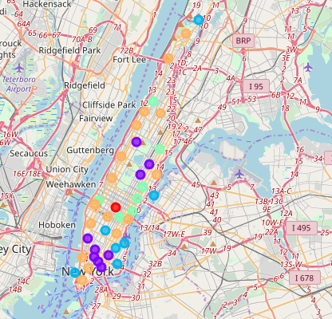

**Result:**

Through Clustering algorithms, the best neighborhoods for Indian restaurants to be set up is Stuyvesant Town.

China town and Marble hill has good presence of Indian restaurants and is not a good neighborhood to have new business



**Conclusion:**

Since all of the goals of project, but still there is still scope for improvement.

Food truck aren’t a new business idea, but there is still tons of opportunity. If there are unique product /service to offer and you know there in demand you have a great chance of succeeding, we will have do a market research open up in the area where there is restaurant .

From the analysis we found that the truck near to the restaurant are the best neighbor for our business model .